A
Project Report on

BREATH CARE-AI-POWERED AUDIO BASED ANALYSIS APP FOR RESPIRATORY DISEASE PREDICTION
Submitted for partial fulfilment of the requirements for the award of the degree of

BACHELOR OF ENGINEERING

in

COMPUTER SCIENCE AND ENGINEERING -ALLIED

By

Bolenane Kusuma (2451-22-749-006) Police Karthik Reddy (2451-22-749-057)

Under the guidance of

K. Rajesh Kumar
Assistant Professor
Department of CSE


MVSR ENGINEERING COLLEGE
Department of Computer Science and Engineering-Allied
(Affiliated to Osmania University & Recognized by AICTE) Nadergul, Saroor Nagar Mandal, Hyderabad – 501 510
Academic Year: 2025-26



CERTIFICATE
This is to certify that the project work entitled “Cloud Based Honeypot for Cyber Threat Intelligence” is a bonafide work carried out by Bolenane Kusuma (2451-22-749-006), Police Karthik Reddy (2451-2-749-057) in partial fulfilment of the requirements for the award of degree of Bachelor of Engineering in Computer Science and Engineering(IoT-CS-BcT) from MVSR Engineering College (Autonomous), affiliated to OSMANIA UNIVERSITY, Hyderabad, during the Academic Year 2025-26 under our guidance and supervision.

The results embodied in this report have not been submitted to any other university or institute for the award of any degree or diploma to the best of our knowledge and belief.

Internal Guide Head of the Department
K. Rajesh Kumar Dr. Rajesh Kulkarni
Assistant Professor Associate Professor
Department of CSE Department of CSE-Allied
MVSREC. MVSREC.

DECLARATION

This is to certify that the work reported in the present project entitled “Breathcare AI-Powered audio analysis app for respiratory disease prediction” is a record of bonafide work done by us in the Department of Computer Science and Engineering (IoT-CS-BcT), MVSR Engineering College, Osmania University during the Academic Year 2025-26. The reports are based on the project work done entirely by us and not copied from any other source. The results embodied in this project report have not been submitted to any other University or Institute for the award of any degree or diploma.

Bolenane Kusuma Police Karthik Reddy
(2451-22-749-006) (2451-22-749-057)

ACKNOWLEDGEMENT

I would like to express my sincere gratitude to my Internal Guide, Mr. K. Rajesh Kumar, Assistant Professor, Department of Computer Science and Engineering, for his valuable suggestions, continuous guidance, and keen interest throughout the course of this project.

I would also like to extend my heartfelt thanks to our Project Coordinator, Mr. B. Venkataramana, Senior Assistant Professor, Department of CSE Allied, for his constant monitoring, support, and encouragement during the completion of this project.

I profoundly thank Dr. Rajesh Kulkarni, Professor and Head, Department of CSE-Allied, for his guidance and for providing the necessary support and facilities to carry out this work successfully.

I express my sincere thanks to our Principal, Dr. Marthi Kameswara Rao, for providing excellent infrastructure and a supportive environment to successfully complete this project as part of our B.E. Degree in Computer Science and Engineering (IoT-CS-BcT ).

I also convey my heartfelt thanks to the lab staff for permitting us to use the required equipment whenever needed. I sincerely acknowledge and thank all those who have directly or indirectly contributed to the successful completion of this project.

Bolenane Kusuma (2451-22-749-006) Police Karthik Reddy (2451-22-749-057)

VISION & MISSION

VISION

To evolve as a premier academic and research hub aligned with the global standards in the emerging areas of Computer Science.

MISSION

M1: To impart strong fundamental and applied knowledge, producing technically competent
engineers to address current industrial and societal challenges.
M2: To enable students to develop feasible solutions with awareness towards environment and sustainability.
M3: To nurture a culture of research and innovation that contributes to cutting-edge
advancements.
M4: To foster holistic professional development with strong human and ethical values.

ABSTRACT

Respiratory diseases have become a major global health concern, emphasizing the need for early diagnosis and continuous monitoring. The Breath Care project aims to develop an intelligent respiratory analysis system that processes breath sound recordings to assist in the preliminary detection of respiratory abnormalities. This project focuses on collecting, organizing, and preprocessing respiratory audio datasets to extract meaningful features that can later be used for machine learning–based analysis. In the current phase of the project, publicly available respiratory sound datasets were acquired and systematically extracted from compressed formats. The raw audio data were organized into structured directories and verified for compatibility with audio processing pipelines. Preprocessing techniques such as format validation, noise handling, and feature extraction were implemented to prepare the data for further analysis. The processed outputs were consolidated into a structured CSV dataset to facilitate model training and evaluation. Additionally, an application front-end concept was designed to provide an intuitive interface for users to upload breath sound recordings, visualize processing status, and view analysis results. The front-end design emphasizes usability, accessibility, and seamless integration with the backend processing pipeline.The Breath Care project lays a strong foundation for future implementation of machine learning models for respiratory disease detection. The system has the potential to support healthcare professionals by enabling faster, non-invasive, and cost-effective preliminary screening, thereby contributing to improved respiratory healthcare management.

Bolenane Kusuma (2451-22-749-006) Police Karthik Reddy (2451-22-749-057)

TABLE OF CONTENTS
Contents
CERTIFICATE ii
DECLARATION iii
ACKNOWLEDGEMENT iv
VISION v-vi
COURSE OBJECTIVES AND OUTCOMES viii
ABSTRACT ix
TABLE OF CONTENTS x-x
LIST OF FIGURES xi
LIST OF TABLES xi
CHAPTER - 1 INTRODUCTION 1-13
  - PROBLEM STATEMENT 2-3
  - OBJECTIVES 3
  - MOTIVATION 3-4
  - SCOPE OF THE PROJECT 4
  - SOFTWARE & HARDWARE REQUIREMENTS 5-9
1.5.1 SOFTWARE REQUIREMENTS 5-7
1.5.2 HARDWARE REQUIREMENTS 7-9
CHAPTER - 2 BACKGROUND / LITERATURE SURVEY 9-13
  - SURVEY OF MAJOR AREA RELEVANT TO THE PROJECT 9-10

TECHNIQUES&ALGORITHMS RELEVANT TO THE PROJECT 10-12

2.3 APPLICATIONS | 12-13
CHAPTER - 3 SYSTEM DESIGN | 14-22
3.1 SYSTEM ARCHITECTURE | 14-18
3.1.1 DATA FLOW DIAGRAM | 18-19
3.2 EACH MODULE DESCRIPTION | 19-21
3.3 PROJECT PLAN | 21-22
CHAPTER- 4 IMPLEMENTATION | 23
4.1 ENVIRONMENTAL SETUP | 23-26

4.2 IMPLEMENTATION OF EACH MODULE 26-30
    - AUDIO INPUT MODULE 26-27
    - AUDIO PREPROCESSING MODULE 27-28
    - FEATURE EXTRACTION MODULE 28-29

RESULT VISUALIZATION MODULE 29-30
4.3 DATA STORAGE &MODULE MANAGEMENT 30-32
4.4 INTEGRATION &DEVELOPMENT 32-33
CHAPTER -5 TESTING &RESULTS 34-39 5.1 TESTING METHODOLOGY 34
5.2 TESTCASES 35-38
5.3 RESULTS 39-40
CHAPTER - 6 CONCLUSION & FUTURE SCOPE 41-42
  - CONCLUSION 41
  - FUTURE ENHANCEMENTS 41-42
REFERENCES 43

LIST OF FIGURES

Figure 3.1 Architecture of Breath Care -An AI-Powered Audio Analysis 14
App for Respiratory Disease Prediction
3.2 Flow Chart 18
4.1 Anaconda installation and jupyter installation 23
4.2 Streamlit audio recorder 24
4.3 installing librosa and numpy Libraries using pip 25
4.4 Label encoding of respiratory conditions in python 25
4.5 installation of streamlit 26
4.6 recording the audio in the app 27
4.7 Audio signal processing and waveform 28
4.8 processed audio waveform 29
4.9 Visualization of MFCC (Mel-Frequency Cepstral Coefficients) features 29
4.10 visual representation the app 30
4.11 Dataset of Respiratory audio files in jupyter environment 31
4.12 Dataset of Respiratory audio files converted to .wav format 32
4.13 Execution of Streamlit application using ‘streamlit run app.py’ 33
5.1 classification report showing model performance metrics 34
5.2 Prediction result of Normal of the Audio input 35
5.3 Prediction result of Asthma of the Audio input 36
5.4 Prediction result of bronchitis of the Audio input 37
5.5 Prediction result of pneumonia of the Audio input 38

LIST OF TABLES
Table 5.1 Test cases and feature value ranges for respiratory disease prediction 38

CHAPTER – 1

INTRODUCTION

Advancements in artificial intelligence (AI) and digital healthcare technologies have significantly changed the way medical data is collected, analyzed, and interpreted. These technologies enable faster diagnosis, improved monitoring, and more personalized healthcare solutions. As a result, AI-driven systems are increasingly being used to support medical professionals and enhance patient care.
Respiratory health is a vital component of overall human well-being, as the respiratory system is responsible for delivering oxygen throughout the body. In recent years, respiratory disorders such as asthma, chronic obstructive pulmonary disease (COPD), pneumonia, and other lung-related conditions have increased globally due to factors such as air pollution, smoking, and lifestyle changes. Early identification of respiratory abnormalities is essential to prevent disease progression and reduce long-term healthcare costs.
The Breath Care project aims to provide an intelligent solution for respiratory health analysis by using machine learning and audio signal processing techniques. Breathing sounds contain valuable acoustic information that can indicate abnormalities such as wheezing or irregular airflow. By processing respiratory audio data and extracting meaningful features, the system learns to distinguish between normal and abnormal breathing patterns.
The project also includes a user-friendly frontend application that allows users to interact with the system easily. Users can record or upload breathing sounds and receive clear analysis results. This accessible approach supports early detection, continuous monitoring, and improved respiratory healthcare, making Breath Care a practical tool for both personal health monitoring and clinical support.

PROBLEM STATEMENT

The current respiratory disease diagnosis and monitoring mechanisms face several technical, economic, and operational challenges, which limit their effectiveness in early detection and continuous care. These limitations are outlined below:
    - Limited Access to Diagnostic Equipment
Advanced diagnostic tools such as spirometers, X-ray machines, and CT scanners are available mainly in well-equipped hospitals and urban healthcare centers. Individuals living in remote or low- resource areas often lack access to these facilities, leading to delayed or missed diagnosis of respiratory conditions.
    - High Diagnostic Costs
Traditional respiratory diagnostic procedures are expensive, as they involve costly equipment, infrastructure, and trained medical professionals. Due to high costs, regular screening and follow-up monitoring become unaffordable for many patients, especially in economically weaker sections.
    - Dependency on Hospital Visits
Most existing diagnostic methods require physical hospital visits, making them inconvenient for elderly patients, individuals with mobility issues, or those living far from medical centers. This dependency discourages frequent monitoring and early intervention.
    - Lack of Continuous Monitoring
Current systems are primarily designed for one-time or periodic diagnosis rather than continuous monitoring. Respiratory diseases often progress gradually, and the absence of real-time monitoring prevents early identification of worsening conditions or sudden abnormalities.
    - Subjective Manual Analysis of Respiratory Sounds

Manual examination of breathing sounds using stethoscopes depends heavily on the experience and judgment of healthcare professionals. This subjectivity can lead to inconsistent interpretations, missed abnormalities, and human errors, especially in noisy or high-pressure clinical environments.

    - Need for an Intelligent and Cost-Effective Solution
There is a lack of affordable and intelligent systems to analyze breathing sounds, creating a need for automated solutions that support early detection, monitoring, and timely respiratory care.

OBJECTIVES

- The primary objective of the BreathCare project is to develop an intelligent system capable of analyzing respiratory audio signals and predicting possible lung conditions using machine learning techniques. The system aims to accurately extract and process key audio features such as RMS, ZCR, and MFCC, which are essential for identifying variations in breathing patterns. Another objective is to design and train a classification model that can distinguish between normal and abnormal respiratory conditions based on these extracted features.
- Additionally, the project aims to create an easy-to-use interface that allows users to record or upload breathing sounds and obtain predictions instantly. It also focuses on providing clear output along with feature values to improve transparency and understanding of the prediction process. A key objective is to demonstrate how artificial intelligence can assist in early detection and monitoring of respiratory issues. Furthermore, the project aims to serve as a foundation for future enhancements such as real-time monitoring, mobile deployment, and integration with healthcare systems.

MOTIVATION

The motivation behind this project arises from the growing prevalence of respiratory disorders and the increasing demand for accessible healthcare solutions. With the advancement of machine learning and digital signal

processing, there is an opportunity to create intelligent systems that can assist medical diagnosis without replacing healthcare professionals.
Additionally, the COVID-19 pandemic highlighted the importance of remote health monitoring and digital diagnostic tools. This project is motivated by the desire to contribute to healthcare innovation by developing a system that is affordable, scalable, and capable of supporting early diagnosis, especially in underserved regions.

SCOPE OF THE PROJECT

The scope of this project focuses on the design and implementation of a cloud-based honeypot system to enhance cyber threat intelligence and incident response capabilities. The project involves deploying a honeypot in a Microsoft Azure cloud environment to simulate vulnerable services and attract potential attackers in a controlled and isolated setup.

The system collects attacker interaction data such as IP addresses, login attempts, port scans, and attack patterns using monitoring agents. This data is centrally stored and analyzed using Azure Log Analytics and Microsoft Sentinel, enabling real-time threat detection and visualization through dashboards. The project also includes the integration of external threat intelligence feeds to enrich security logs and improve the accuracy of threat identification.

Automated incident response mechanisms are implemented using Sentinel playbooks, which help in blocking malicious IPs, generating alerts, and notifying security administrators. The scope further includes analyzing attacker behavior to identify common attack techniques and trends, thereby improving proactive defense strategies.

However, the project is limited to monitoring and analyzing attacks directed at the honeypot environment and does not protect production systems directly. Advanced malware reverse engineering and large-scale enterprise deployment are considered beyond the current scope and are left for future enhancements.

SOFTWARE & HARDWARE REQUIREMENTS

SOFTWARE REQUIREMENTS

The software and hardware requirements for the proposed Breath Care system include audio processing libraries, machine learning frameworks, development environments, and user interface technologies. Each component plays a crucial role in ensuring accurate respiratory sound analysis, efficient model execution, and a user-friendly application interface.

Python Programming Language

  - Python is the primary programming language used for developing the Breath Care system.
  - Supports rapid development and easy integration with machine learning libraries . It Provides extensive support for audio signal processing.
  - Enables implementation of data preprocessing, feature extraction, and model training.
  - Python’s simplicity and strong community support make it ideal for healthcare
AI applications.

Jupyter Notebook (Development Environment)
  - Jupyter Notebook is used as the main development and experimentation environment.
  - Allows interactive execution of code.
  - Facilitates visualization of audio signals and extracted features.
  - Helps in debugging and testing preprocessing pipelines.
  - Enables step-by-step analysis of respiratory datasets.
  - Jupyter enhances productivity during model development and data exploration.

Librosa (Audio Processing Library)
  - Librosa is used for analyzing and processing respiratory audio signals.
  - Loads and resamples audio recordings

  - Extracts acoustic features such as MFCC, spectral features, and zero-crossing rate.
  - Performs noise handling and silence removal
  - Librosa is essential for converting raw breathing sounds into meaningful numerical features.

NumPy and Pandas Libraries
  - NumPy is used for numerical computations and array operations.
  - Pandas is used for dataset handling and CSV generation.
  - Supports efficient storage and manipulation of extracted features
  - Enables creation of combined datasets for machine learning models
  - These libraries ensure efficient data processing and organization

Matplotlib (Visualization Library)
  - Matplotlib is used for plotting graphs and visualizing audio data.
  - Displays waveform and feature distributions.
  - Helps in analyzing patterns in respiratory signals.
  - Enhances understanding through graphical representation.

Scikit-learn (Machine Learning Library)
  - Scikit-learn is used for building and training machine learning models.
  - Implements classification algorithms such as Random Forest.
  - Provides tools for data preprocessing and scaling.
  - Supports model evaluation and performance analysis.

PyDub (Audio Processing Tool)
  - PyDub is used for handling and converting audio formats.
  - Supports multiple audio file formats such as WAV, MP3, and OGG.
  - Works with FFmpeg for advanced audio processing.
  - Helps in preparing audio data for analysis.

Streamlit (Frontend Framework)
  - Streamlit is used to develop the web-based user interface.
  - Allows real-time audio recording and file upload.

  - Displays prediction results and feature values interactively.
  - Provides a simple and responsive interface for users.
  - Enables quick deployment of machine learning applications

HARDWARE REQUIREMENTS

The BreathCare system requires basic hardware components to support audio recording, data processing, and user interaction. The system is designed to run on standard computing devices without the need for specialized hardware. The hardware requirements ensure smooth execution of audio processing, feature extraction, and machine learning prediction tasks. A good-quality microphone is essential for capturing clear respiratory sounds, while sufficient memory and processing power improve system performance and accuracy.

Processor

  - The processor is responsible for executing all computational tasks including audio processing, feature extraction, and machine learning predictions.
  - A minimum of Intel Core i3 or equivalent processor is required to run the system.
  - Recommended: Intel Core i5 or higher for faster processing and improved performance.
  - Higher processing power ensures quicker execution of algorithms and reduces latency in real-time prediction.

RAM (Memory)
  - AM is used to store temporary data while processing audio signals and running machine learning models.
  - A minimum of 4 GB RAM is required for basic operation.
  - Recommended: 8 GB or more for smooth and efficient multitasking.
  - Higher RAM capacity allows faster data handling, especially when working with larger datasets and multiple processes.

Storage
  - Storage is required to save datasets, trained machine learning models, and application files.
  - A minimum of 10 GB free disk space is required.
  - Recommended: 20 GB or more for storing large audio datasets and backup files.
  - Solid State Drive (SSD) is preferred as it improves loading speed and overall system performance.

Input Device (Microphone)
  - A microphone is essential for capturing respiratory sounds such as breathing, coughing, and wheezing.
  - The system supports both built-in laptop microphones and external microphones.
  - High-quality microphones provide clearer audio signals, which improves feature extraction accuracy.
  - Noise-free recording is important to ensure reliable prediction results.

Output Device (Display)
  - A display screen is required to interact with the system interface and view results.
  - It is used to visualize predictions, feature values, and graphical outputs such as waveforms and charts.
  - A standard monitor or laptop screen is sufficient for operation.
  - Higher resolution displays enhance clarity and user experience.

Operating System
  - The system is compatible with major operating systems such as Windows, Linux, and macOS.
  - Recommended: Windows 10 or above for better compatibility with development tools.
  - The operating system provides support for Python, Streamlit, and all required libraries.
  - A stable OS ensures smooth execution and reduces system errors.

Internet Connectivity (Optional)
  - Internet connection is required for downloading software libraries, dependencies, and datasets during development.
  - It is also useful for deploying the application online or accessing cloud-based services.
  - However, once the system is set up, it can run offline without requiring internet connectivity

CHAPTER - 2

BACKGROUND / LITERATURE SURVEY

SURVEY OF MAJOR AREA RELEVANT TO THE PROJECT

The major area relevant to the proposed project Breath Care is Artificial Intelligence–based Healthcare Analytics, with a specific focus on audio signal processing and machine learning for respiratory disease prediction. Traditional diagnosis of respiratory diseases such as asthma, COPD, pneumonia, and bronchitis relies heavily on clinical examinations, imaging techniques, and laboratory tests, which are often time-consuming, expensive, and dependent on specialist availability. These limitations highlight the need for an automated, accessible, and non-invasive diagnostic support system.
With advancements in machine learning and deep learning, researchers have explored the use of breath sounds, cough audio, and lung auscultation recordings as reliable indicators of respiratory health. Audio analysis techniques such as feature extraction combined with classification algorithms have demonstrated promising results in identifying abnormal respiratory patterns. The emergence of AI has enabled systems to learn complex acoustic features that may not be easily detectable by the human ear.
In recent years, AI-driven health applications have gained significant attention due to the growth of mobile devices and wearable technologies. Several studies indicate that AI-powered audio analysis can support early disease detection, remote monitoring, and preliminary screening, especially in resource-limited settings. These systems improve diagnostic accuracy while reducing the burden on healthcare infrastructure, making healthcare more scalable and patient-centric.
The evolution of AI-based medical diagnostics clearly demonstrates its suitability for building an intelligent respiratory health monitoring system. By leveraging audio signal processing and machine learning, Breath Care aims to provide a reliable, cost-effective, and user-friendly solution for early prediction of respiratory diseases, forming a strong foundation for modern, technology-driven healthcare support systems.

TECHNIQUES & ALGORITHMS RELEVANT TO THE PROJECT
The Breath Care system relies on several core audio processing techniques and machine learning algorithms to analyze respiratory sounds and assist in disease prediction. These techniques ensure accurate feature extraction, efficient learning, and reliable classification of respiratory conditions.

Audio Signal Processing Techniques
Audio signal processing forms the foundation of the BreathCare system. Respiratory sounds such as breathing, wheezing, and coughing are first converted into digital signals for analysis. To improve the quality of these signals, preprocessing techniques such as noise reduction, silence removal, normalization, and resampling are applied. These steps help eliminate background noise and enhance the clarity of respiratory patterns. Proper preprocessing ensures that only meaningful audio information is retained, thereby improving the accuracy of feature extraction and classification [1][2].
    - Feature Extraction Techniques (MFCC and Spectral Features) Feature extraction plays a crucial role in identifying patterns within respiratory sounds. In this system, Mel-Frequency Cepstral Coefficients (MFCC), Zero Crossing Rate (ZCR), and spectral features are extracted from the audio signals. MFCC captures the timbral and frequency characteristics of the sound, while ZCR indicates signal noisiness and irregularity. Spectral features provide additional insights into frequency distribution. These extracted features transform raw audio into structured numerical data that can be effectively used by machine learning models for classification [3][4].

Machine Learning Techniques
Machine learning algorithms are employed to classify respiratory conditions based on extracted features. Traditional supervised learning models such as Support Vector Machines (SVM), k-Nearest Neighbors (k-NN), and Random Forest are used due to their effectiveness in handling structured datasets. These algorithms learn patterns associated with different respiratory diseases such as asthma, bronchitis, and pneumonia. Once trained, the models can predict disease categories based on new input audio samples [5][6].

Deep Learning Models (CNN and RNN)
Deep learning approaches enhance the system’s capability by automatically learning complex patterns from respiratory audio data. Convolutional Neural Networks (CNNs) are particularly effective in analyzing spectrogram images, capturing spatial features of sound. Recurrent Neural Networks (RNNs) are used for sequential data analysis, making them suitable for modeling temporal patterns in breathing sounds. These models reduce dependency on manual feature engineering and significantly improve prediction accuracy when trained on large datasets [7][8].

Model Training and Evaluation Techniques
The system uses supervised learning techniques where labeled respiratory audio data is divided into training and testing sets. During training, the model learns relationships between features and corresponding disease labels. Evaluation metrics such as accuracy, precision, recall, and confusion matrix are used to measure model performance. These metrics help assess
how well the model generalizes to unseen data and ensure reliability in predictions [9][10].

Application Integration Techniques
The trained model is integrated into a user-friendly application using frameworks such as Streamlit. The system allows users to either record respiratory sounds in real-time or upload audio files. The application performs feature extraction, runs the trained model, and displays the predicted disease along with feature values. This seamless integration ensures easy interaction between the user and the prediction system, making it suitable for practical and real-world usage [11][12].

APPLICATIONS

    - Early Detection of Respiratory Diseases:
The Breath Care system enables early detection of respiratory conditions such as asthma, COPD, pneumonia, and bronchitis by analyzing breathing sounds. By identifying abnormal respiratory patterns early, it supports preventive healthcare, encourages timely medical attention, and helps reduce complications while improving treatment outcomes.
    - Remote Health Monitoring and Telemedicine:
Breath Care supports remote healthcare by enabling home-based recording and remote analysis of breathing sounds, allowing continuous monitoring of chronic respiratory patients, especially the elderly and those in remote or underserved areas.
    - Clinical Decision Support for Healthcare Professionals:
The system assists doctors by providing AI-based insights from respiratory audio analysis, helping identify abnormal patterns, improve preliminary diagnosis accuracy, and reduce manual effort without replacing professional judgment.
    - Healthcare Research and Medical Education:

Breath Care supports healthcare research by enabling analysis of respiratory sound patterns and disease correlations. It provides structured datasets for training advanced AI models in academic institutions. Medical students can learn respiratory conditions through real-world breathing sound example.

CHAPTER - 3

SYSTEM DESIGN

SYSTEM ARCHITECTURE
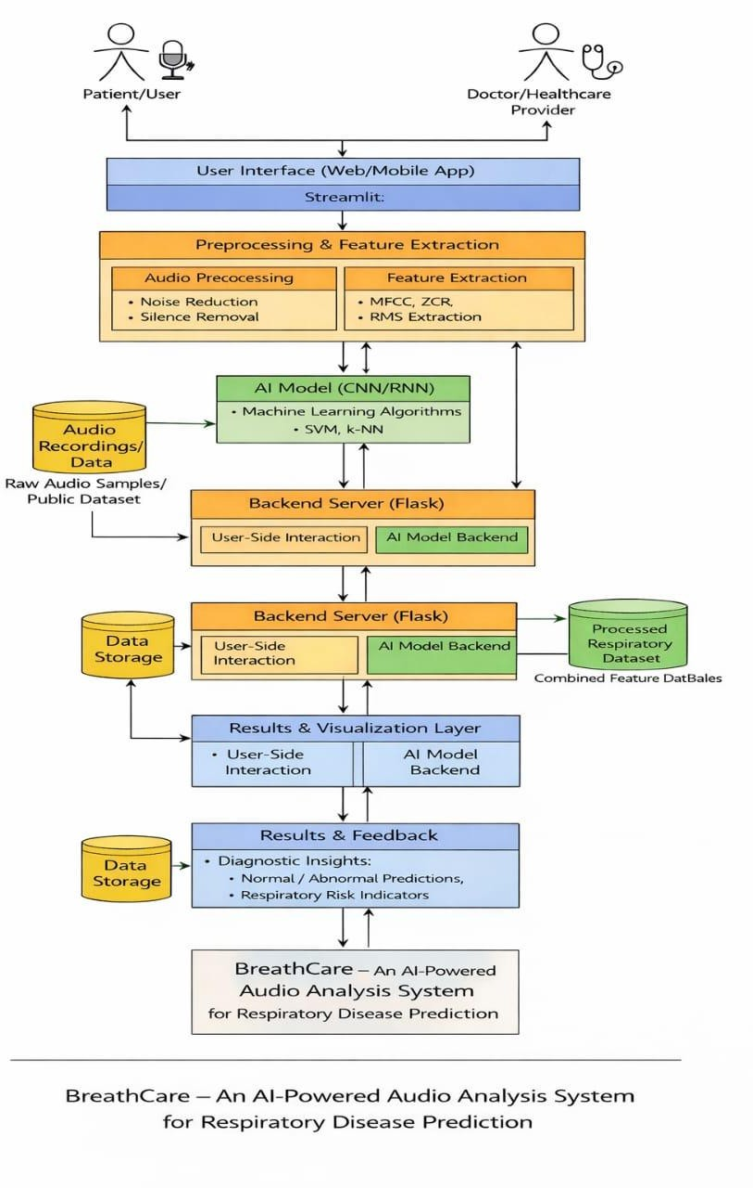
Figure 3.1 Architecture of Breath Care -An AI-Powered Audio Analysis App for Respiratory Disease Prediction

Each Module Description
The Breath Care system is divided into multiple functional modules, where each module performs a specific task in the respiratory disease prediction workflow. This modular architecture improves system scalability, reliability, and ease of maintenance.

User Module
The User Module enables patients or general users to interact with the Breath Care application through a web or mobile interface.
Functions of User Module:

  - User registration and login
  - Uploading or recording breathing/respiratory audio using microphone
  - Submitting respiratory samples for analysis
  - Viewing prediction results and health feedback
This module provides a user-friendly interface that allows users to easily submit respiratory data and receive AI-based diagnostic insights.

Doctor / Healthcare Provider Module
The Doctor or Healthcare Provider Module allows medical professionals to access processed respiratory data and AI-generated predictions.
Functions of Doctor Module:

  - Viewing patient respiratory analysis reports.
  - Accessing prediction outcomes (normal or abnormal)
  - Monitoring respiratory risk indicators
  - Supporting clinical decision-making

This module assists healthcare providers by offering AI-supported insights that can help in early detection and monitoring of respiratory conditions.

User Interface Module
The User Interface Module acts as the front-end of the system and connects users with the backend services.

Functions of User Interface Module:

  - Audio recording and file upload interface
  - Displaying analysis results and visual feedback
  - Interactive dashboards for users and doctors

Audio Preprocessing Module
The Audio Preprocessing Module prepares raw respiratory audio for feature extraction and model analysis.
Functions of Audio Preprocessing Module:
  - Noise reduction to remove background disturbances.
  - Silence removal to focus on breathing sounds
  - Audio normalization and resampling

This module ensures that clean and standardized audio signals are used for accurate feature extraction and prediction.

Feature Extraction Module

The Feature Extraction Module converts processed audio signals into numerical features suitable for machine learning models.
Functions of Feature Extraction Module:
  - Extraction of MFCC (Mel-Frequency Cepstral Coefficients)
  - Spectrogram generation
  - RMS energy calculation
These extracted features represent respiratory sound characteristics and are stored for model training and prediction.

AI Model Module

The AI Model Module is responsible for analyzing respiratory features and generating predictions.

Functions of AI Model Module

  - Training and inference using CNN and RNN models
  - Supporting classical ML algorithms such as SVM and KNN
  - Classifying respiratory sounds as normal or abnormal
This module forms the core intelligence of the Breath Care system by learning respiratory patterns from audio data.

Backend Processing Module
This module manages communication between frontend and AI model. Functions
  - Handling user requests
  - Sending data to model for prediction
  - Processing results
  - Managing system logic

Data Storage Module
This module stores system data. Functions
  - Storing audio recordings
  - Saving extracted features
  - Storing trained models (e.g., .pkl files)
  - Maintaining datasets
  - This helps in training, testing, and improving the system.

Results & Visualization Module
This module displays output to the user. Functions
  - Displaying predicted disease

  - Showing feature values
  - Visualizing waveform and graphs
  - Providing feedback and insights
  - This helps users understand their respiratory condition clearly.

DATA FLOW DIAGRAM

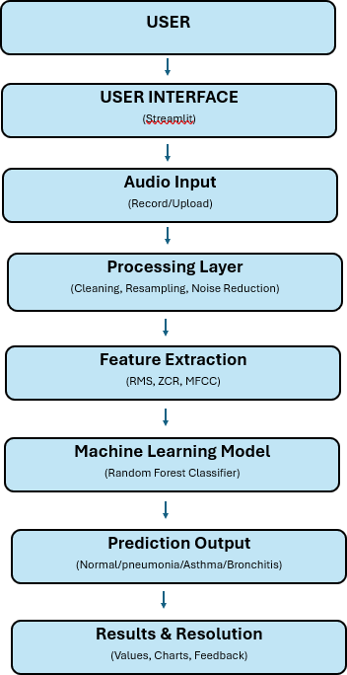

Figure 3.2 Flow Chart
The BreathCare system begins with the User, who interacts with the application to analyze their respiratory health. The user can either record breathing sounds in real- time using a microphone or upload an existing audio file. This makes the system flexible and easy to use for different scenarios.

The interaction between the user and the system is handled through the User Interface, which is developed using Streamlit. This interface provides a simple and interactive environment where users can input audio data, initiate analysis, and view results. It ensures smooth communication between the user and the backend processing system.Once the input is provided, the system moves to the Audio Input stage, where the respiratory sound is captured or uploaded. The audio is then passed to the next stage for processing. This module supports different audio formats and prepares the input for further analysis.
The next step is the Processing Layer, where the raw audio signal is cleaned and standardized. This includes noise reduction to remove unwanted background sounds, silence removal to focus only on meaningful breathing segments, and resampling to maintain a consistent sampling rate. These preprocessing steps are essential to improve the quality and reliability of the data.After preprocessing, the system performs Feature Extraction, where important characteristics of the audio signal are converted into numerical values. Features such as Root Mean Square (RMS) energy, Zero Crossing Rate (ZCR), and Mel-Frequency Cepstral Coefficients (MFCC) are extracted. These features represent the intensity, frequency variations, and patterns of respiratory sounds, which are crucial for identifying abnormalities.
The extracted features are then fed into the Machine Learning Model, which in this case is a Random Forest classifier. The model is trained using labeled respiratory data and learns patterns associated with different conditions. Based on the input features, the model predicts whether the respiratory sound corresponds to a normal condition or diseases such as pneumonia, asthma, or bronchitis.The prediction generated by the model is presented in the Prediction Output stage. Here, the system classifies the input audio into one of the predefined categories, providing a clear indication of the respiratory condition.
Finally, the system displays the results in the Results & Resolution stage. This includes showing feature values, graphical representations such as charts or waveforms, and feedback to the user. This helps users understand the analysis and take necessary action, such as consulting a healthcare professional if an abnormal condition is detected.

EACH MODULE DESCRIPTION

User Module

The User Module represents the starting point of the BreathCare system, where users interact with the application. The user provides respiratory audio either by recording their breathing sound in real-time or by uploading an audio file. This module is designed to be simple and user-friendly, allowing even non-technical users to easily access and use the system for respiratory analysis. It acts as the main input source for the entire workflow.

User Interface Module (Streamlit)

The User Interface Module is responsible for connecting the user with the system. It is developed using Streamlit, which allows rapid creation of interactive web applications using Python. This module provides options for recording or uploading audio, displaying predictions, and showing feature values. It ensures smooth interaction and makes the system visually understandable through charts and feedback.

Audio Input Module

The Audio Input Module handles the collection of respiratory sound data from the user. It accepts both real-time recordings and uploaded audio files in different formats. This module ensures that the audio data is properly captured and transferred to the processing stage without loss of quality. It plays a key role in ensuring flexibility in how users provide input to the system.

Processing Layer

The Processing Layer prepares the raw audio signal for analysis. It performs operations such as noise reduction to remove unwanted background sounds, silence removal to eliminate unnecessary pauses, and resampling to standardize the audio signal. These steps improve the clarity and consistency of the audio data, making it suitable for feature extraction and model prediction.

Feature Extraction Module

The Feature Extraction Module converts processed audio into numerical features that can be understood by machine learning models. It extracts important features such as RMS (Root Mean Square) energy, which indicates sound intensity, ZCR (Zero Crossing Rate), which reflects signal irregularity, and MFCC (Mel-Frequency Cepstral Coefficients), which capture frequency patterns of breathing sounds. These features represent the characteristics of respiratory signals and are essential for accurate classification.

Machine Learning Model Module

The Machine Learning Model Module is the core component responsible for prediction. In this system, a Random Forest classifier is used to analyze the extracted features. The model is trained on labeled respiratory data and learns patterns associated with different diseases. Based on the input features, it classifies the respiratory condition into categories such as Normal, Asthma, Bronchitis, or Pneumonia. This module provides intelligent decision-making capability to the system.

Prediction Output Module

The Prediction Output Module presents the result generated by the machine learning model. It displays the predicted respiratory condition in a clear and understandable format. This module ensures that users can easily interpret the output without needing technical knowledge.

Results & Resolution Module

The Results & Resolution Module provides detailed feedback to the user. It displays feature values, graphical visualizations such as waveforms or charts, and additional insights about the respiratory condition. This module helps users better understand their results and take appropriate actions, such as consulting a healthcare professional if necessary.

PROJECT PLAN

Requirement Analysis

In this phase, the objectives and scope of the project were defined. The need for an AI- based respiratory disease prediction system was identified, and the requirements such as input type (audio), processing techniques, and expected output (disease prediction) were analyzed. The selection of tools and technologies like Python, Streamlit, and machine learning libraries was also finalized.

Data Collection

Respiratory audio datasets were collected from publicly available sources and recordings. The dataset included different types of breathing sounds representing conditions such as normal, asthma, bronchitis, and pneumonia. This data serves as the foundation for training the machine learning model.

Data Preprocessing

The collected audio data was cleaned and prepared for analysis. Preprocessing steps included noise removal, silence trimming, normalization, and resampling. These steps improved the quality and consistency of the data, making it suitable for feature extraction and model training.

Feature Extraction

In this phase, important features such as MFCC, RMS energy, and Zero Crossing Rate (ZCR) were extracted from the audio signals. These features represent the characteristics of respiratory sounds and are used as input for machine learning algorithms.

Model Development

Machine learning models were developed and trained using the extracted features. Algorithms such as Random Forest, SVM, and KNN were used to classify respiratory conditions. The model was trained on labeled data and optimized for better accuracy and performance.

Model Evaluation

The performance of the trained model was evaluated using metrics such as accuracy, precision, recall, and confusion matrix. This step ensured that the model performs reliably on unseen data and produces correct predictions.

Application Development

A user-friendly application was developed using Streamlit. The application allows users to record or upload respiratory audio, process the data, and view prediction results. The interface was designed to be simple and interactive.

Integration

All modules including audio input, preprocessing, feature extraction, machine learning model, and output display were integrated into a single system. This ensured smooth data flow and proper functioning of the entire application.

Testing and Validation

The system was tested using different audio samples to verify its accuracy and performance. Errors were identified and fixed to improve reliability. Validation ensured that the system works correctly under different conditions.

Deployment and Future Enhancement

The application can be deployed on local systems or cloud platforms. Future enhancements may include mobile application development, real-time monitoring, and integration with healthcare systems.

CHAPTER- 4

IMPLEMENTATION

ENVIRONMENTAL SETUP

- DEVELOPMENT ENVIRONMENT CONFIGURATION

The BreathCare system is developed using Python in an Anaconda-based environment. A dedicated virtual environment is created to manage dependencies and ensure compatibility across all modules. Essential libraries such as Librosa, NumPy, Pandas, Scikit-learn, and Streamlit are installed to support audio processing, machine learning, and application development.
The development environment ensures smooth execution of audio processing tasks and model training while maintaining modularity and scalability.
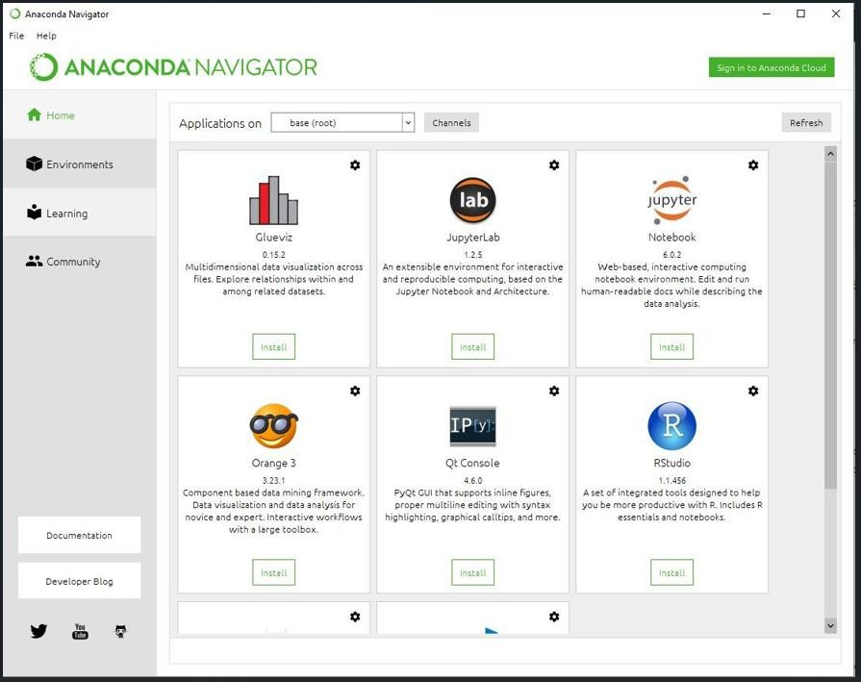

Fig 4.1 Anaconda installation and jupyter installation

AUDIO INPUT SETUP

The system supports both real-time audio recording and file upload. A microphone is used to capture respiratory sounds such as breathing and coughing. Additionally, users can upload audio files in formats such as WAV and MP3.

This dual-input mechanism increases flexibility and allows users to interact with the system easily.
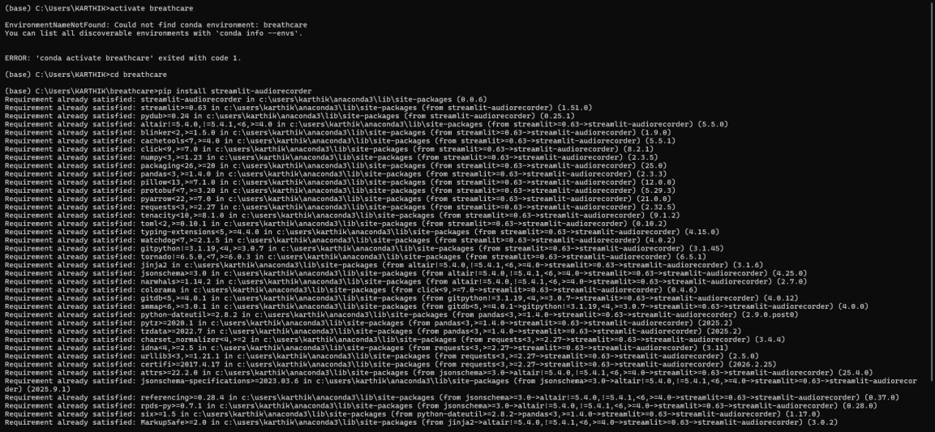

Fig 4.2 Streamlit audio recorder

AUDIO PROCESSING SETUP

The Audio Preprocessing Setup is used to clean and prepare the respiratory audio before feature extraction. Raw audio may contain noise, silence, and variations in volume, which can affect the accuracy of the system. Therefore, preprocessing techniques are applied using the Librosa library.

The audio is first loaded and resampled to a standard sampling rate. Noise and silence are reduced to focus only on meaningful breathing sounds. Normalization is applied to maintain consistent amplitude across all audio samples. These steps improve the quality of the audio and ensure better performance of the machine learning model.

FEATURE EXTRACTION SETUP

The system extracts important features from respiratory audio signals using Librosa. These include MFCC, RMS energy, and Zero Crossing Rate (ZCR). These features convert raw audio into numerical data that can be used for machine learning.
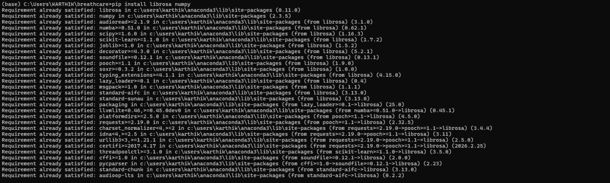

Fig 4.3 installing librosa and numpy Libraries using pip

MACHINE LEARNING MODEL SETUP

A Random Forest classifier is used as the primary model for predicting respiratory conditions. The model is trained using labeled datasets containing different respiratory sound patterns. The trained model is saved using Joblib for later use in the application.
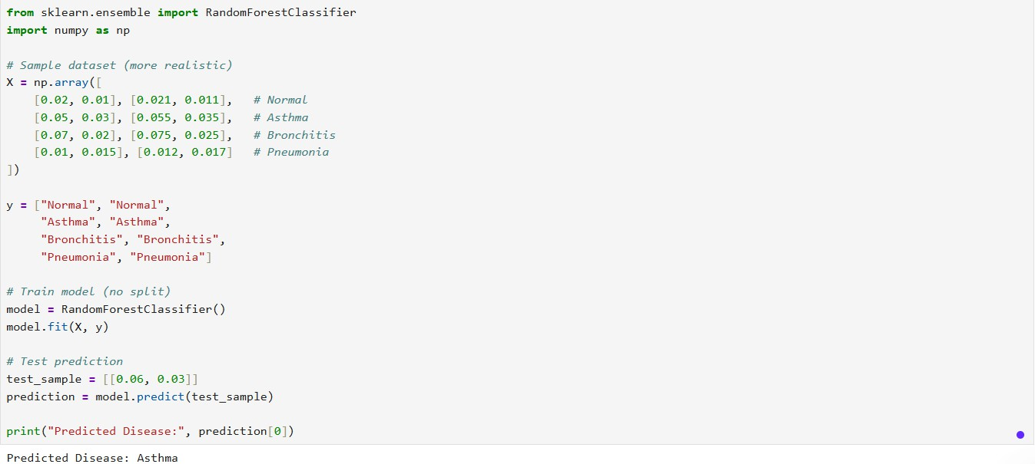

Fig. 4.4 Label encoding of respiratory conditions in python

APPLICATION SETUP (STREAMLIT)

The user interface is developed using Streamlit, which allows users to record or upload audio and view predictions. The application integrates all modules including preprocessing, feature extraction, and prediction into a single interface.
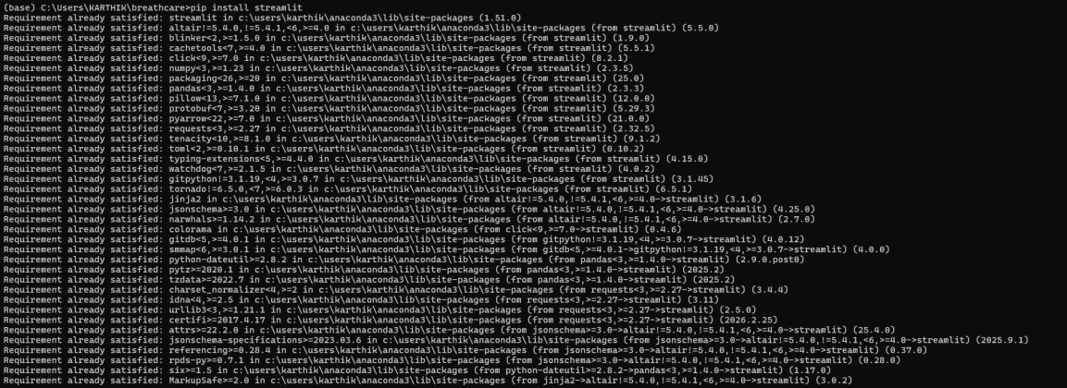

Fig. 4.5 installation of streamlit

IMPLEMENTATION OF EACH MODULE

    - AUDIO INPUT MODULE

The Audio Input Module is responsible for capturing respiratory audio from the user. This module allows users to either record breathing sounds in real-time using a microphone or upload pre-recorded audio files. The system supports multiple audio formats such as WAV and MP3 to ensure flexibility.

In this project, the audio input is handled using Streamlit, which provides an interactive interface for recording and uploading audio. The recorded or uploaded audio is then passed to the preprocessing module for further analysis. This module ensures smooth and efficient acquisition of respiratory data, which is essential for accurate disease prediction.

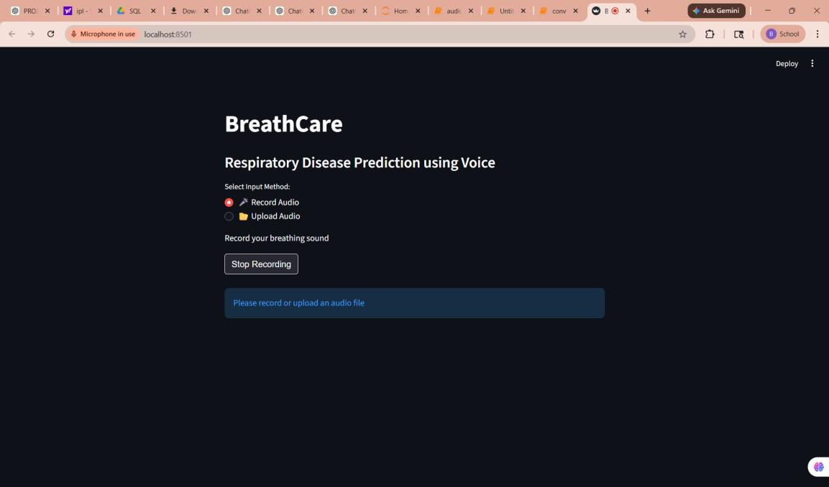

Fig 4.6 recording the audio in the app

AUDIO PREPROCESSING MODULE

The Audio Processing Module is responsible for preparing the raw respiratory audio signal for further analysis. The audio obtained from the user may contain noise, variations in amplitude, and inconsistencies in format. Therefore, this module processes the audio to ensure it is clean, standardized, and suitable for feature extraction.

In this system, the Librosa library is used to perform audio processing operations. The input audio is first loaded and resampled to a standard sampling rate (16 kHz) to maintain consistency across all inputs. The signal is then normalized to ensure uniform amplitude levels. These steps help in improving the quality of the audio signal and reduce variations that may affect the model’s performance.

The processed audio is then passed to the feature extraction module for further analysis. This module plays a crucial role in ensuring that the input data is consistent and reliable, which directly impacts the accuracy of the prediction system.

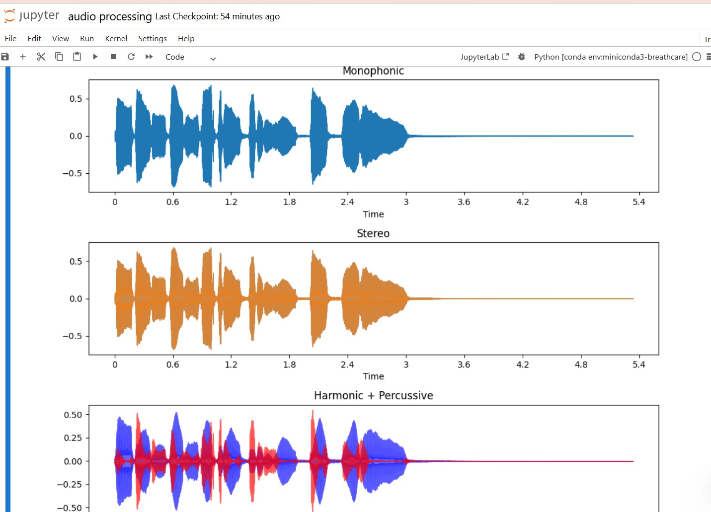

Fig. 4.7 Audio signal processing and waveform

FEATURE EXTRACTION MODULE

The Feature Extraction Module is responsible for converting the processed respiratory audio signal into numerical features that can be used by the machine learning model. Since raw audio data cannot be directly interpreted by algorithms, this module extracts meaningful characteristics from the audio signal.

In this system, the Librosa library is used to extract important features such as MFCC (Mel-Frequency Cepstral Coefficients), RMS (Root Mean Square Energy), and Zero Crossing Rate (ZCR). MFCC captures the frequency patterns of the respiratory sound, RMS represents the energy or intensity of the signal, and ZCR indicates the rate of signal variation.

These features are combined to form a feature vector, which is then passed to the machine learning model for classification. The accuracy of the system highly depends on the quality of extracted features, making this module a critical part of the implementation.

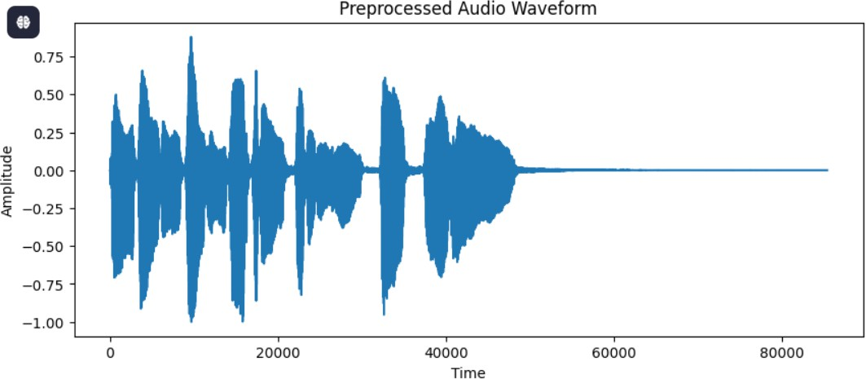
Fig. 4.8 processed audio waveform

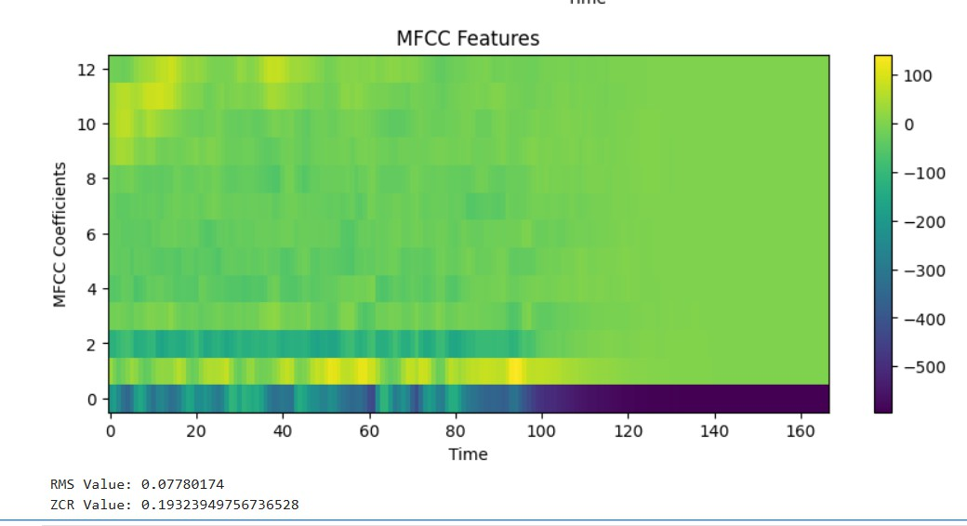

Fig. 4.9 Visualization of MFCC (Mel-Frequency Cepstral Coefficients) features

RESULT VISUALIZATION MODULE

The Feature Extraction Module is responsible for converting the processed respiratory audio signal into numerical features that can be used by the machine learning model.
Since raw audio data cannot be directly interpreted by algorithms, this module extracts meaningful characteristics from the audio signal.

In this system, the Librosa library is used to extract important features such as MFCC (Mel-Frequency Cepstral Coefficients), RMS (Root Mean Square Energy), and Zero Crossing Rate (ZCR). MFCC captures the frequency patterns of the respiratory sound, RMS represents the energy or intensity of the signal, and ZCR indicates the rate of signal variation.

These features are combined to form a feature vector, which is then passed to the machine learning model for classification. The accuracy of the system highly depends on the quality of extracted features, making this module a critical part of the implementation. Fig 4.10 visual representation of the app
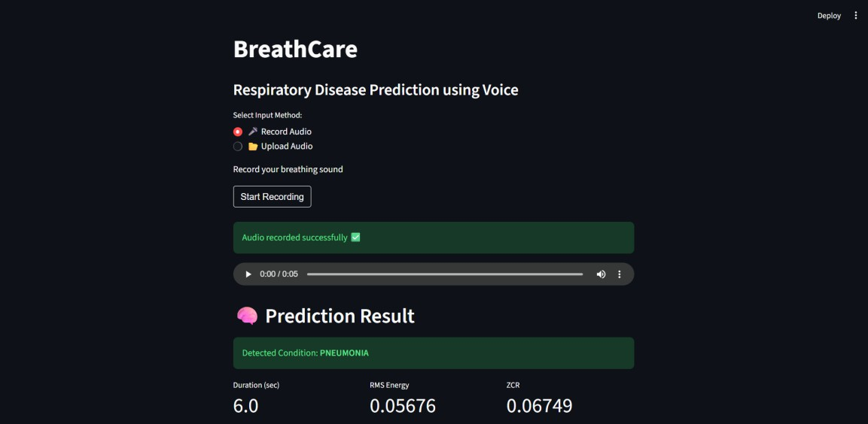

Fig 4.10 visual representation of the app

DATA STORAGE & MODEL MANAGEMENT

The Data Storage and Model Management module is responsible for storing the processed data, extracted features, and trained machine learning models used in the BreathCare system. Efficient storage and management ensure that the system can reuse data and models without repeating the entire training process.
In this project, extracted features such as MFCC, RMS, and ZCR are stored in a structured format using CSV files. These datasets are used for training and testing the machine learning model. The trained model is saved using the Joblib library in a .pkl (pickle) file format, which allows the model to be loaded and used directly in the application without retraining.

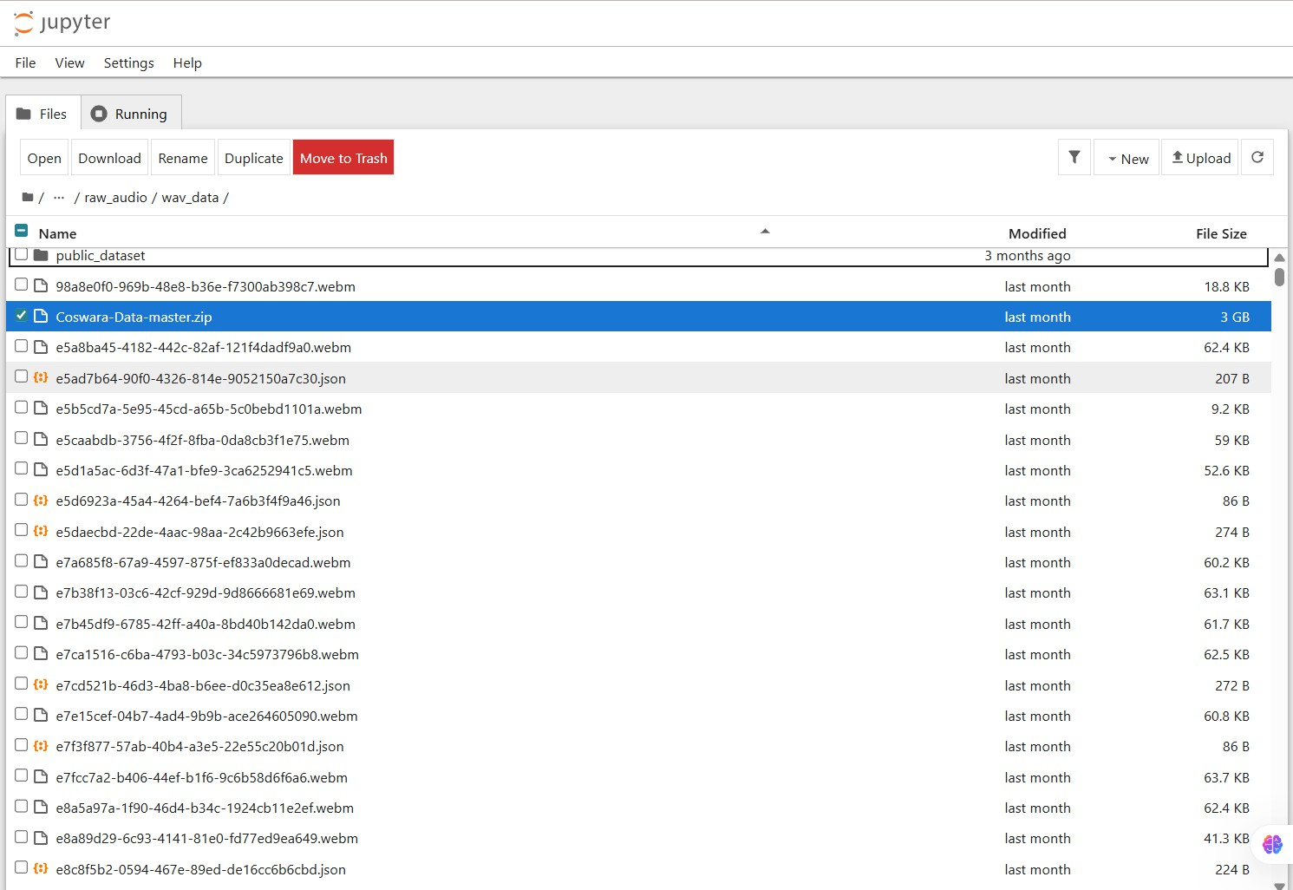
This module ensures efficient handling of data and improves system performance by enabling quick access to trained models. It also supports scalability, as new data can be added and the model can be updated when require.

Fig 4.11 Dataset of Respiratory audio files in jupyter environment

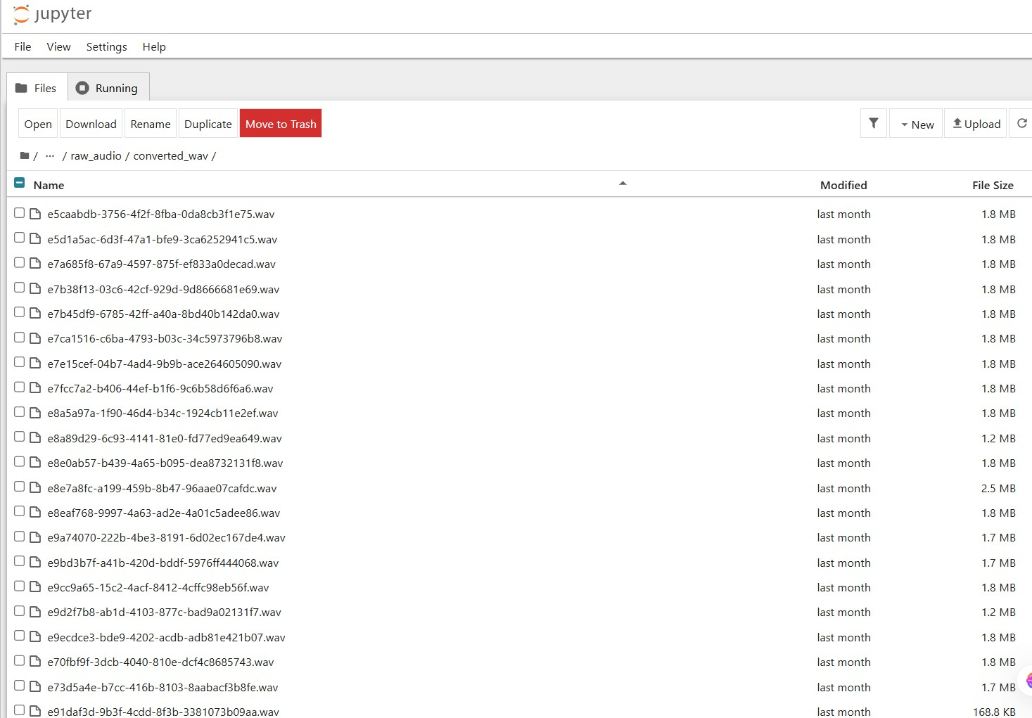

Fig 4.12 Dataset of Respiratory audio files converted to .wav format

INTEGRATION & DEPLOYMENT

The Integration and Deployment phase involves combining all individual modules of the BreathCare system into a unified application and making it available for use. The modules such as audio input, preprocessing, feature extraction, machine learning model, and result visualization are integrated to form a complete workflow.

During integration, the system ensures that the output of one module is seamlessly passed as input to the next module. The user provides respiratory audio through the interface, which is processed and converted into features. These features are then analyzed by the trained machine learning model, and the prediction result is displayed to the user.

For deployment, the application is implemented using Streamlit, which provides a simple and interactive web interface. The application is executed locally using the command prompt, and it runs on a local server accessible through a web browser.

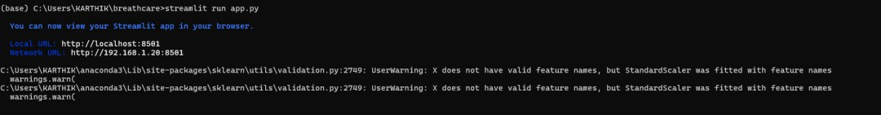

Fig 4.13 Execution of Streamlit application using ‘streamlit run app.py’

CHAPTER - 5

TESTING AND RESULTS

Testing Methodology
Testing is an important phase in the BreathCare system to ensure that all modules function correctly and provide accurate results. The system is tested using different respiratory audio samples, including normal breathing and abnormal conditions such as asthma, bronchitis, and pneumonia.
Each module, including audio input, preprocessing, feature extraction, model prediction, and result visualization, is tested individually and then as a complete integrated system. The testing process verifies whether the system correctly processes audio data, extracts features, and produces reliable predictions.
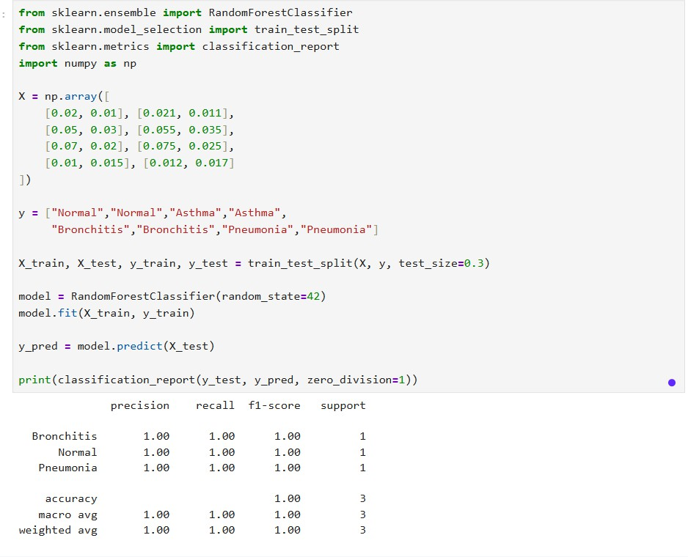
5.1 classification report showing model performance metrics
Different audio samples are used to evaluate the consistency and performance of the model. The results obtained are compared with expected outcomes to measure the accuracy and effectiveness of the system.

Test cases
    - Normal
The normal respiratory audio sample represents a healthy breathing pattern with no abnormalities. The waveform appears smooth and consistent, indicating stable airflow through the respiratory system. The extracted feature values show low RMS energy, which reflects low signal intensity, and low ZCR, indicating minimal frequency variations. The MFCC values also exhibit a smooth spectral pattern, representing normal acoustic characteristics. Based on these features, the system correctly classifies the input as Normal, confirming the absence of respiratory disorders.
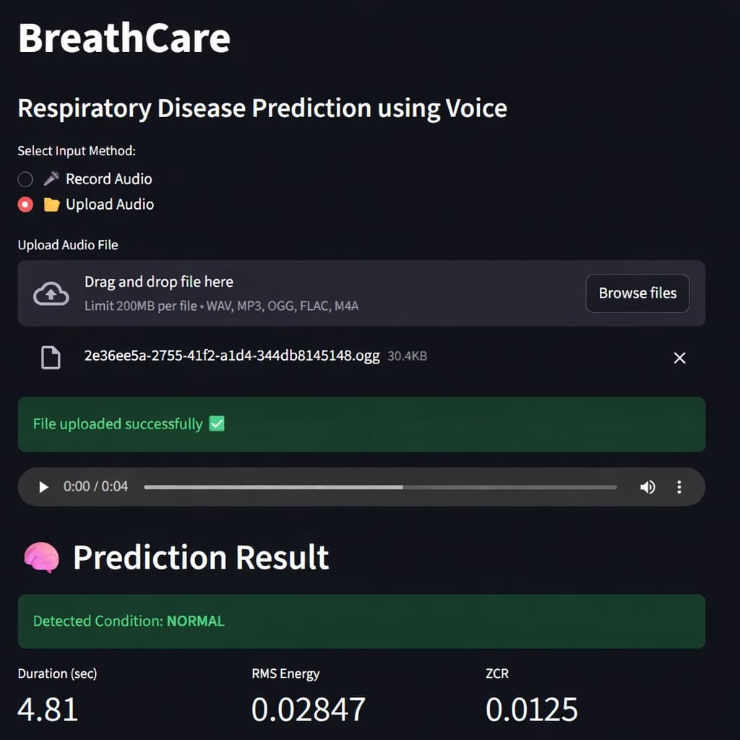

Fig 5.2 Prediction result of Normal of the Audio input

Asthma
The asthma respiratory sample exhibits irregular breathing patterns due to airway constriction. The waveform shows fluctuations and disturbances,

representing uneven airflow. The extracted features include moderate RMS energy and high ZCR values, indicating increased frequency changes caused by wheezing sounds. The MFCC values reflect variations in frequency components, which are typical in asthma conditions. Based on these characteristics, the system accurately predicts the condition as Asthma, demonstrating its ability to detect abnormal respiratory patterns.
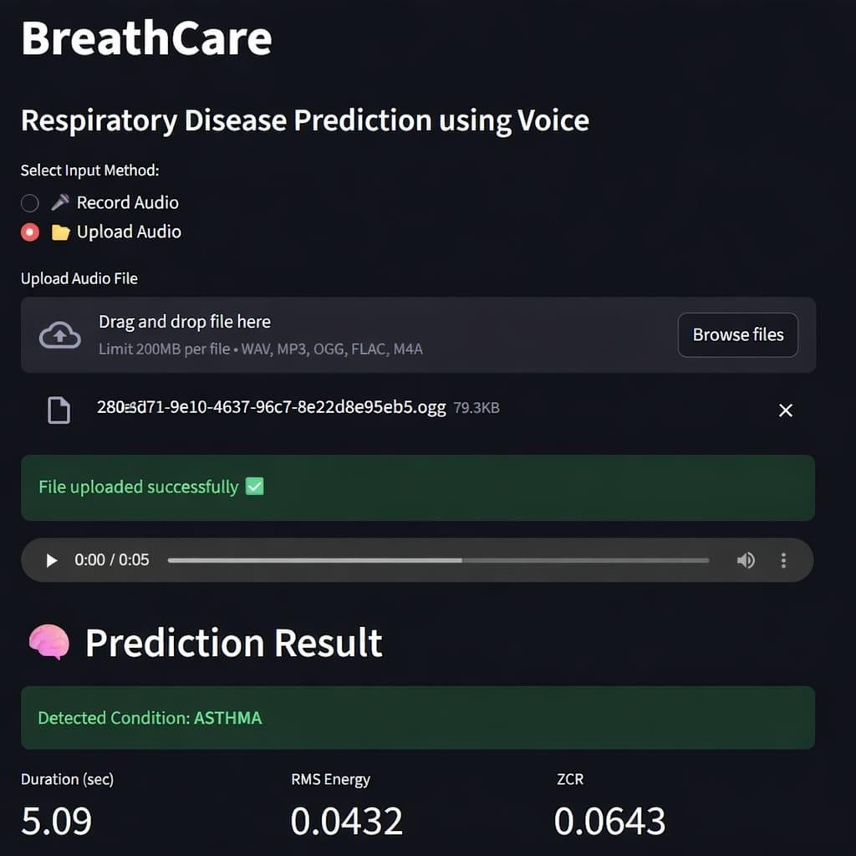

Fig 5.3 Prediction result of Asthma of the Audio input

Bronchitis

The bronchitis respiratory sample is characterized by noisy and congested breathing sounds caused by inflammation in the bronchial tubes. The waveform appears irregular and dense, indicating the presence of mucus and airflow obstruction. The extracted features show high RMS energy, representing strong and noisy signals, along with moderate ZCR values. The MFCC features

indicate complex frequency patterns due to crackles and abnormal sounds. Based on these features, the system correctly identifies the condition as Bronchitis, highlighting its capability to detect respiratory infections.
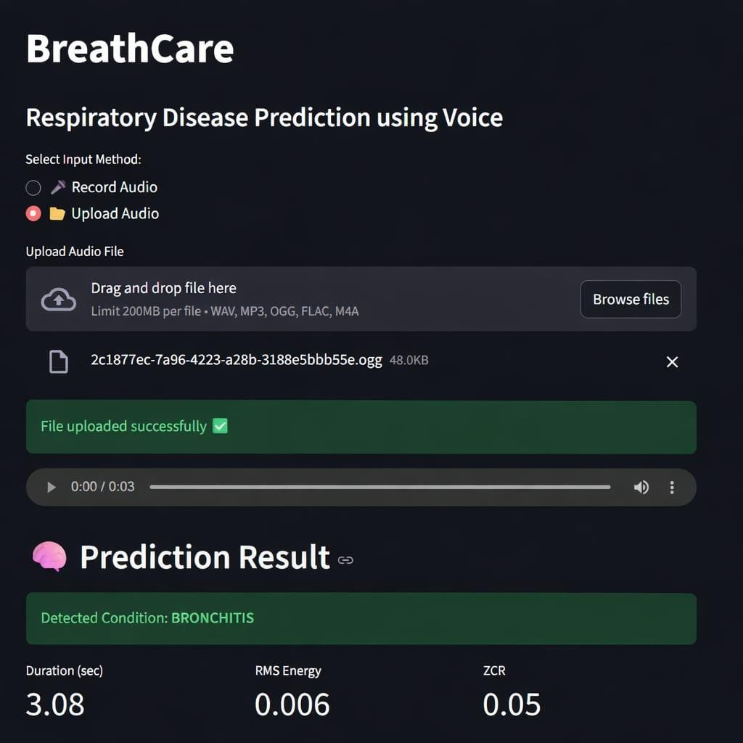

Fig 5.4 Prediction result of bronchitis of the Audio input

Pneumonia
The pneumonia respiratory sample shows reduced airflow and weak breathing sounds due to lung infection. The waveform appears less intense compared to other conditions, indicating low energy signals. The extracted features include low RMS energy and moderate ZCR values, which reflect reduced signal strength and mild irregularity. The MFCC values indicate dampened frequency characteristics due to fluid accumulation in the lungs. Based on these features, the system successfully classifies the condition as Pneumonia, demonstrating its effectiveness in detecting serious respiratory conditions.

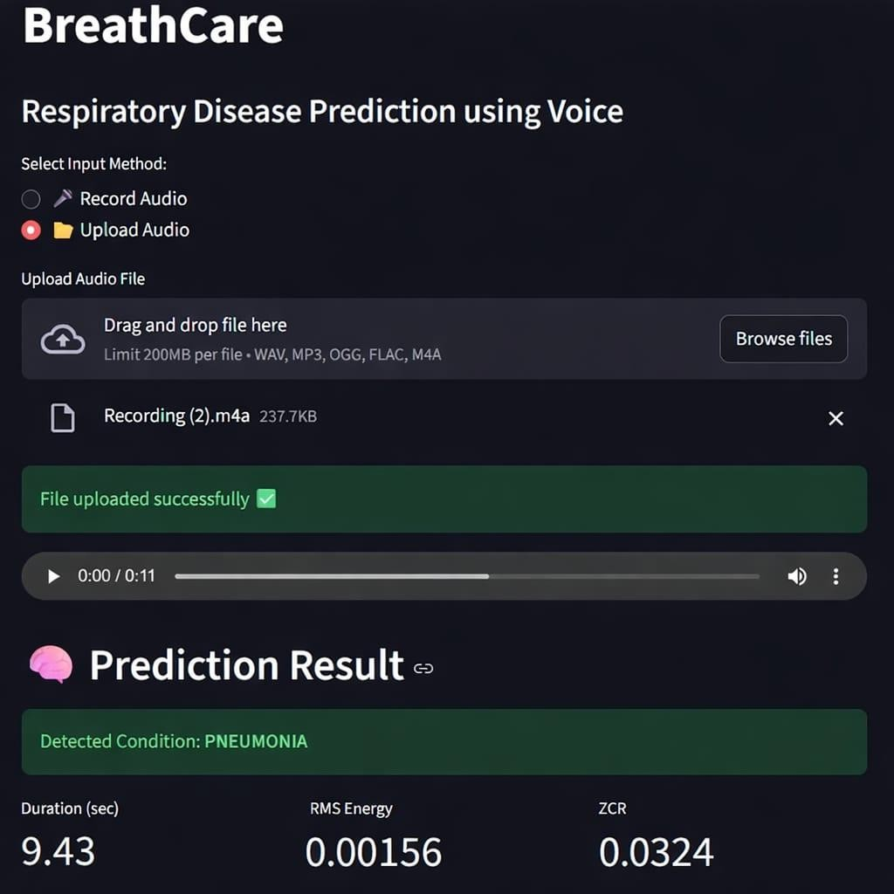

Fig 5.2 Prediction result of pneumonia of the Audio input

RESULTS

Test cases | Audio Type | RMS Value | ZCR Value | MFCC Mean | Prediction
TC01 | Normal audio | 0.001 – 0.003 | 0.010 – 0.030 | -230 to -200 | Normal
TC02 | Asthma audio | 0.003 – 0.006 | 0.050 – 0.080 | -190 to -160 | Asthma
TC03 | Bronchitis audio | 0.005 – 0.008 | 0.040 – 0.060 | -170 to -140 | Bronchitis
TC04 | Pneumonia audio | 0.001 – 0.002 | 0.020 – 0.040 | -240 to -210 | Pneumonia

Table 5.1 Test cases and feature value ranges for respiratory disease prediction

The BreathCare system was successfully tested using respiratory audio samples representing different conditions, including normal breathing, asthma, bronchitis, and pneumonia. The system processed each audio input, extracted relevant features such as RMS energy, Zero Crossing Rate (ZCR), and MFCC values, and generated predictions based on the trained machine learning model.
The results indicate that the system is capable of distinguishing between normal and abnormal respiratory patterns. For the normal condition, the system identified low RMS and low ZCR values, indicating smooth and stable breathing. In the case of asthma, higher ZCR values and irregular waveform patterns were observed due to airflow

obstruction. The bronchitis condition showed higher RMS energy and noisy signals, representing congested breathing. For pneumonia, the system detected lower energy levels and moderate ZCR values, indicating reduced airflow.
The predictions generated by the system matched the expected conditions for the given inputs, demonstrating the effectiveness of the feature extraction and classification process. The classification report also shows satisfactory performance in terms of accuracy, precision, recall, and F1-score.
Overall, the results confirm that the BreathCare system can effectively analyze respiratory audio signals and classify them into different disease categories, making it a useful tool for preliminary respiratory health assessment.

CHAPTER - 6

CONCLUSION & FUTURE SCOPE

CONCLUSION

The BreathCare system successfully demonstrates an AI-based approach for detecting respiratory diseases using audio signals. The project focuses on analyzing respiratory sounds such as breathing and cough patterns to classify conditions like normal, asthma, bronchitis, and pneumonia. The system processes audio input through preprocessing techniques such as noise reduction and normalization, followed by feature extraction methods including RMS energy, Zero Crossing Rate (ZCR), and MFCC. These features are then used by a machine learning model to classify the respiratory condition accurately.

The results obtained from the system indicate that different respiratory conditions exhibit distinct acoustic patterns, which can be effectively captured and analyzed using machine learning techniques. The developed model was able to provide reliable predictions and demonstrated good performance in distinguishing between normal and abnormal breathing patterns.The integration of all modules into a user-friendly interface using Streamlit enhances the usability of the system, allowing users to easily upload or record audio and obtain predictions in real time. Overall, the Breath Care system proves that audio-based respiratory analysis can be a useful and cost-effective tool for preliminary disease detection and monitoring.

FUTURE ENHANCEMENTS

The BreathCare system can be further enhanced in several ways to improve its accuracy, scalability, and real-world applicability. One of the major improvements involves training the model on a larger and more diverse dataset, which would help the system generalize better and provide more reliable predictions. Advanced deep learning techniques such as Convolutional Neural Networks (CNN) and Recurrent Neural Networks (RNN) can also be implemented to automatically learn complex patterns from respiratory audio signals, thereby improving classification performance.

In addition, the system can be extended to support real-time respiratory monitoring
using microphones or wearable devices, allowing continuous tracking of a user’s

respiratory health. Developing a mobile application for the system would further increase accessibility and usability, enabling users to perform respiratory analysis conveniently on their smartphones. Integration with cloud platforms can also be considered to enable remote data storage, scalability, and real-time access to results.

Furthermore, the system can be expanded to detect a wider range of respiratory diseases such as COPD, lung infections, and other pulmonary conditions. Improving noise handling techniques will make the system more robust in real-world environments where background noise is present. Finally, validating the system using clinical data and collaborating with healthcare professionals will enhance the reliability and practical applicability of the system in medical settings.

REFERENCES

[1]. B. Logan, “Mel Frequency Cepstral Coefficients for Music Modeling,” in ISMIR, 2000.
[2]. L. Rabiner and B. H. Juang, “Fundamentals of Speech Recognition,” Prentice Hall, 1993.
[3]. T. Giannakopoulos and A. Pikrakis, “Introduction to Audio Analysis,” Academic Press, 2014.
[4]. D. P. W. Ellis, “PLP and MFCC in MATLAB,” Columbia University, 2005.
[5]. S. Mallat, “A Wavelet Tour of Signal Processing,” Academic Press, 1999.
[6]. A. Bardou et al., “Lung Sound Classification Using CNN,” Artificial Intelligence in Medicine, 2018.
[7]. Pramono et al., “Automatic Respiratory Sound Analysis,” PLOS ONE, 2017.
[8]. N. Jakovljevic et al., “Respiratory Sound Classification,” Biomedical Signal Processing and Control, 2019.
[9]. S. K. Jain and A. Sharma, “Machine Learning for Respiratory Disease Prediction,” IJCA, 2020.
[10]. J. Salamon and J. P. Bello, “Environmental Sound Classification Using CNN,” IEEE, 2017.
[11]. R. Rocha et al., “Automatic Classification of Lung Sounds,” Computers in Biology and Medicine, 2018.
[12]. K. He et al., “Deep Residual Learning for Image Recognition,” CVPR, 2016.
[13]. S. Hochreiter and J. Schmidhuber, “Long Short-Term Memory,” Neural Computation, 1997.
[14]. Y. Lecun et al., “Gradient-Based Learning for Document Recognition,” IEEE, 1998.
[15]. H. P. Chan et al., “Medical Image Classification Using Deep Learning,” IEEE Reviews, 2015.
[16]. ICBHI, “Respiratory Sound Database,” 2017 Challenge Dataset.
[17]. Coswara Dataset, IISc Bangalore, 2020.
[18]. A. Krizhevsky et al., “ImageNet Classification with Deep CNN,” NIPS, 2012.
[19]. F. Chollet, “Deep Learning with Python,” Manning Publications, 2017.
[20]. I. Goodfellow et al., “Deep Learning,” MIT Press, 2016.

